**EXPERIMENT-5**

**Title: 5. Use of different SQL clauses and join**

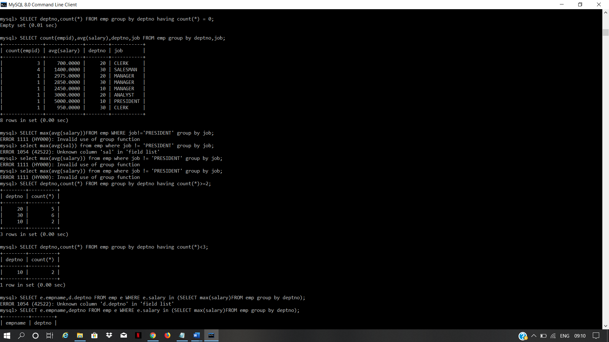

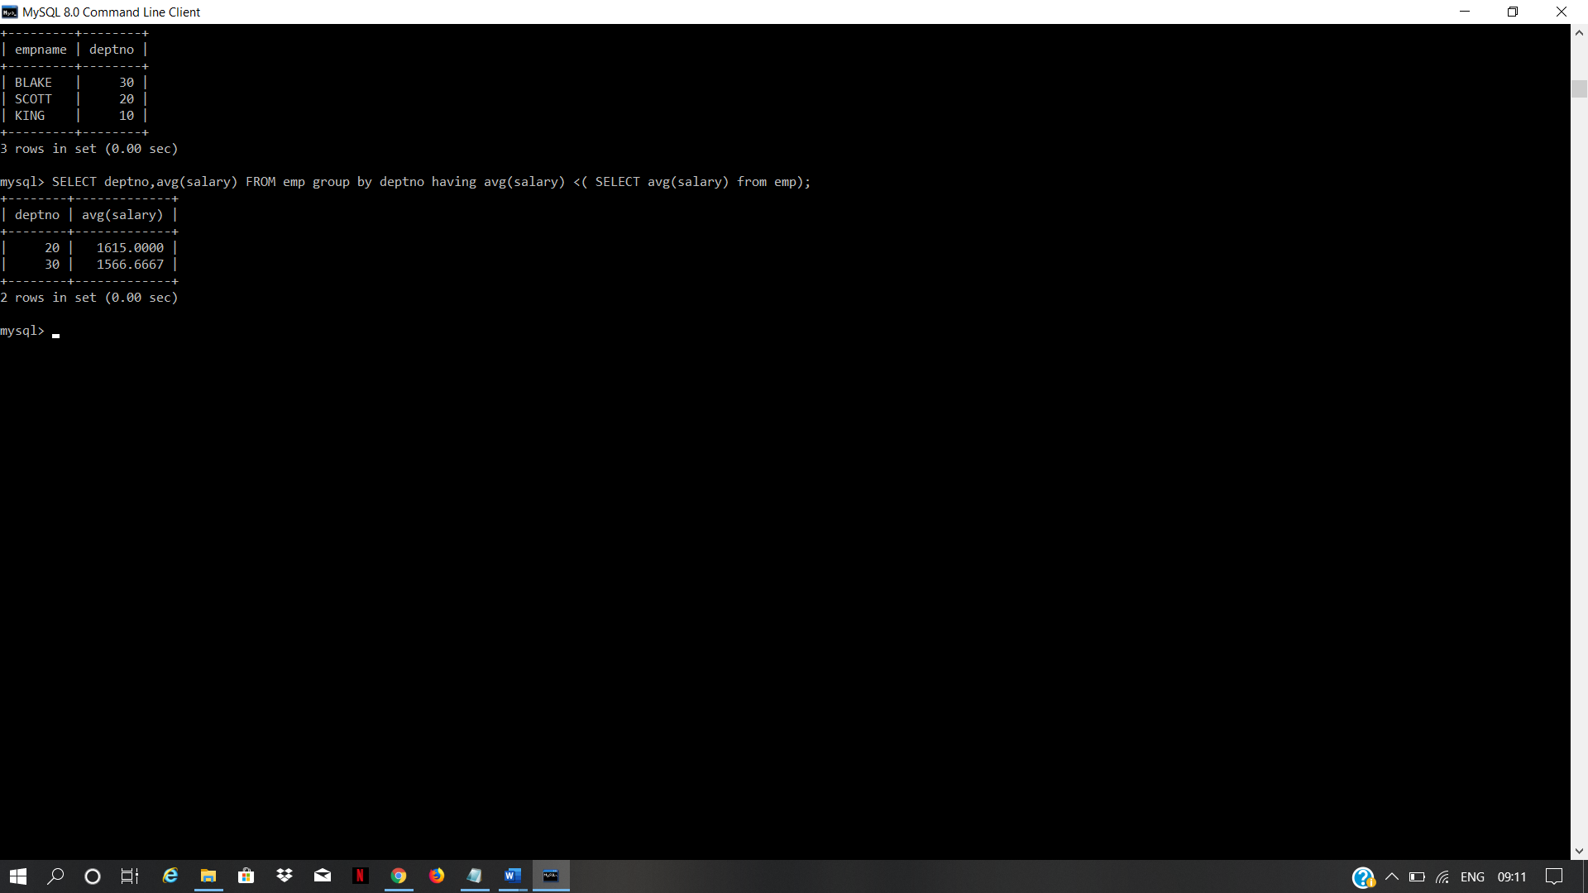

**EXPERIMENT-5**

**Title: 5. Use of different SQL clauses and join**

1. List the Deptno where there are no emps.
2. List the No.of emp’s and Avg salary within each department for each job.
3. Find the maximum average salary drawn for each job except for ‘President’.
4. List the department details where at least two emps are working.
5. List the no. of emps in each department where the no. is more than 3.
6. List the names of the emps who are getting the highest sal dept wise.
7. List the Deptno and their average salaries for dept with the average salary less than the averages for all departments.